**Day-3 (Assignment-3)**

# **Agile Software Process and its Principles**

## **Agile Software Process**

In Agile Any Agile Software Process is characterized in a manner that

addresses a variety of key assumptions concerning the bulk of

software projects:

* It is troublesome to predict before that software needs will persist

and can be amended. it’s equally troublesome to predict

however client priorities can be amended because of the project

payoff.

* For many sorts of software, style and construction are

interleaved. That is, each activity ought to be performed in order

that style models are verified as they’re created. it’s troublesome

to predict what proportion of design is critical before construction

is employed to prove the look.

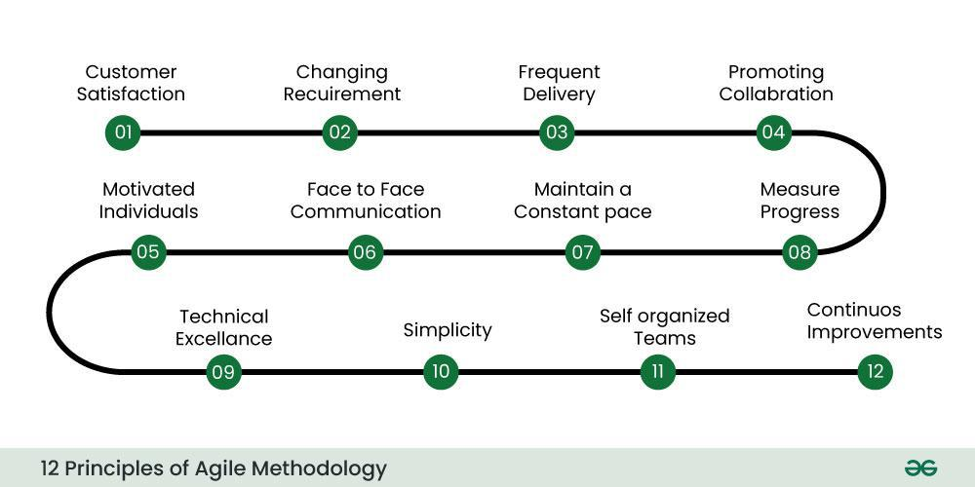

## **Agile Principals**

1. **Customer satisfaction through early and continuous delivery of valuable software**: Agile processes prioritize delivering working software frequently, typically in iterations or sprints, ensuring that the customer receives value early and often.
2. **Welcome changing requirements, even late in development**: Agile processes harness change for the customer's competitive advantage. Requirements are expected to evolve throughout the project, and Agile teams are prepared to adapt to these changes.
3. **Deliver working software frequently, from a couple of weeks to a couple of months, with a preference to the shorter timescale**: Agile emphasizes the importance of delivering tangible results at regular intervals, promoting a sustainable pace of work and quick feedback loops.
4. **Business people and developers must work together daily throughout the project**: Agile projects thrive on close collaboration between business stakeholders and development teams. This collaboration ensures shared understanding, quick decision-making, and alignment with business goals.
5. **Build projects around motivated individuals, give them the environment and support they need, and trust them to get the job done**: Agile teams are self-organizing and empowered. They are trusted to make decisions and are provided with the necessary resources and support to achieve project goals.
6. **The most efficient and effective method of conveying information to and within a development team is face-to-face conversation**: Agile values direct communication and considers face-to-face interactions (or virtual equivalents) the most effective way to convey information, resolve issues, and foster collaboration.
7. **Working software is the primary measure of progress**: Agile focuses on delivering working software incrementally. Progress is measured by the functionality that is completed and available for review or deployment.
8. **Agile processes promote sustainable development. The sponsors, developers, and users should be able to maintain a constant pace indefinitely**: Agile teams maintain a sustainable pace by avoiding overwork and burnout. This ensures that they can maintain high productivity over the long term.
9. **Continuous attention to technical excellence and good design enhances agility**: Agile teams prioritize quality and technical excellence to maintain flexibility and responsiveness to change. This includes ongoing refinement of technical practices and design principles.
10. **Simplicity—the art of maximizing the amount of work not done—is essential**: Agile teams focus on delivering the essential features with minimal complexity. They prioritize the elimination of unnecessary work and streamline processes to maximize efficiency.
11. **The best architectures, requirements, and designs emerge from self-organizing teams**: Agile promotes self-organizing teams that are empowered to make decisions and adapt to changes. Through collaboration and iteration, teams evolve their solutions to meet evolving requirements.
12. **At regular intervals, the team reflects on how to become more effective, then tunes and adjusts its behaviour accordingly**: Agile teams regularly reflect on their processes, seeking opportunities for improvement. Continuous improvement is integral to Agile, with adjustments made iteratively to enhance effectiveness.